DESIGN OF A CONTINUOUS-PROCESS GARI FRYING MACHINE

by

E.U. ODIGBOH AND S.F. AHMED
Department of Agricultural Engineering
University of Nigeria, Nsukka.

(Manuscript received May, 1982)

ABSTRACT:
A prototype gari frying machine, designed to faithfully simulate the traditional manual frying technique, was fabricated and tested. The prototype consists of a 1.7m long semi-circular frying trough of 57 cm diameter, and a gang of sixteen spring-loaded spatula-like paddles evenly spaced within the trough. Electric-motor driven and designed to oscillate through about 180⁰ at 40 reversals per minute, the paddles press the automatically/continuously metered gari mash against the hot trough when moving in one direction and then scrape the mash off, stir it and move it forward when moving in the opposite direction. The prototype produces a continuous flow of fried gari at 66 kg/hr. The prototype has a provision for manual operation when it produces 20 to 45 kg of gari per hour.

1. INTRODUCTION:
In terms of number of consumers, the most important and by far, the most common processed foods from cassava are farinha de mandioca originated in Brazil and gari in West and Central Africa. Gari as well as farinha has a scale of processing that ranges from 0.2 to 5 metric tons of roots per day for individual family units and small-to-medium-scale village processors [1] to 50 to 100 metric tons per day for large industrial processors. More than 200 million people consume gari/ farinha in varying amounts; for the majority of people from West Africa, gari forms the main meal of the day. The technological requirements for large-scale gari processing differ from those for small-scale operation. Large-scale gari processing machinery, in the main, are now becoming available and are already in use. Examples are the PRODA, FABRICO and FIIRO/NEWELL DUNFORD processing plants, even though these plants still require various modifications and improvements to improve their performance. But, appropriate technologies in terms of improved equipment and devices for small-scale processing of gari are not as well developed, if at all in existence. Yet, there is evidence to show that the small-scale operations may have points of efficiency and certain advantages over the large-scale enterprises [2].

2. THE GARI FRYING PROCESS (GARIFICATION)
As shown in the processing flow-chart of Fig. 1. Frying is the terminal major unit operation in gari production. Gari frying is a complex process. Mere stirring of the pulverized and sifted mash in a vessel over a fire would yield a product which, though resembling gari visually, would not in fact be gari. Traditionally, gari is fried by women in shallow earthen-ware or cast-iron pans over a wood fire. The women use spatula-like paddles of wood or calabash sections to press the sifted mash against the hot surface of the frying pan, quickly scrape the mash off the hot surface to avoid burning, vigorously stir the mash and then repeat the series

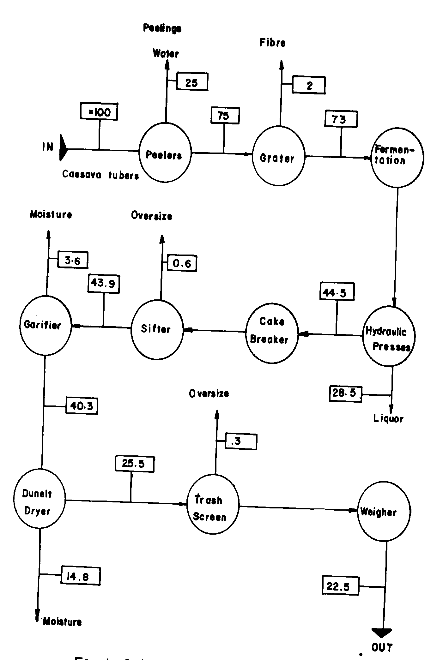
Fig. i. Gari processing flow chart.(Figures are weight percent)

of operations. Thus, frying of gari involves repetitive pressing, scrapping and stirring of the sifted mash in a frying pan over a fire. The pressing of the mash against the hot surface of the frying pan results in the toasting of the gari particles; starch so pressed out from the starch granules coats the gari particles and is partially gelatinized to form a thin enveloping film. Thus, under the microscope, a gari particle is seen to be composed of a small grain of cassava coated by a thin film of gelatinized cassava starch. When placed in water or otherwise wetted, the grain absorbs moisture through the partially gelatinized starch film and swells. Unless the frying is correctly done, the product will not exhibit this characteristic swelling as some early workers researching the mechanization of gari frying found out. In this respect, the term "garification" has come to be used to call attention to the fact that the process involves more than drying over a fire. Sometimes, about half-way through the45-60mm duration of the manual frying process, some palm oil is added to give coloured gari which may be various shades of yellow depending on the amount of oil added. It is said that the oil prevents the burning of the gari and provides a flavor favoured by some consumers. After frying, the hot gari is spread out to cool and has a moisture content of 13% to 16%, wet basis, which is the usual range of moisture content of fresh gari found in the local markets. At this range of moisture content, the gari can keep for about two weeks without deterioration, provided that the gari is initially uniformly cooled and subsequently stored under conditions that do not permit re-absorption of moisture from the ambient environment [3].
As can be appreciated from the description of the process, manual frying of gari is a hot business; the woman sits near the fire for the hour-long batch process, sweating profusely and pressing, scrapping and stirring continuously to obtain an average of 3.5kg of gari[4]. Naturally, the manual frying process is not quite hygienic as there is ample opportunity for contamination from sundry sources including drups of sweat from the body of the operator. The large gari processing systems mentioned earlier in this section have, of course, mechanized the garification process. Still, there is a need to develop a gari frying machine suitable for the small and medium-scale processors who account for over 95% of the gari consumed in most of Africa. It is to serve this major group of processors that the prototype frying machine described here was developed.

3. DESCRIPTION OF THE MACHINE
The photograph of the prototype gari frying machine is given in Fig. 2.

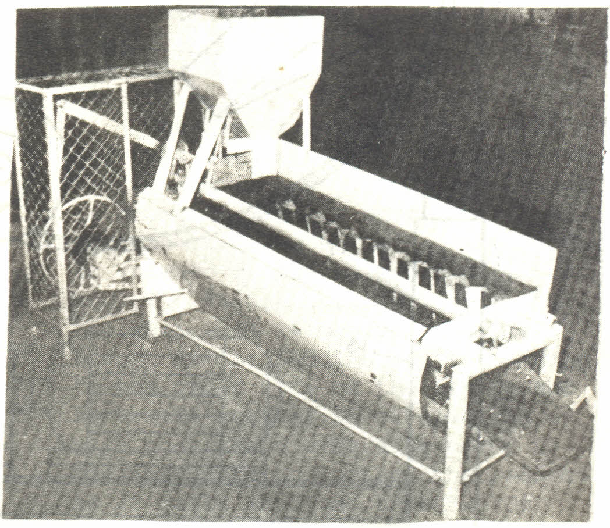
Fig 2. Photograph of Prototype Gari Frying Machine

The prototype is designed to faithfully simulate the manual frying technique described above. It consists of sixteen spring-loaded paddles carried on 1.75m long shaft which is mounted axially in such way as to locate the spatula-like

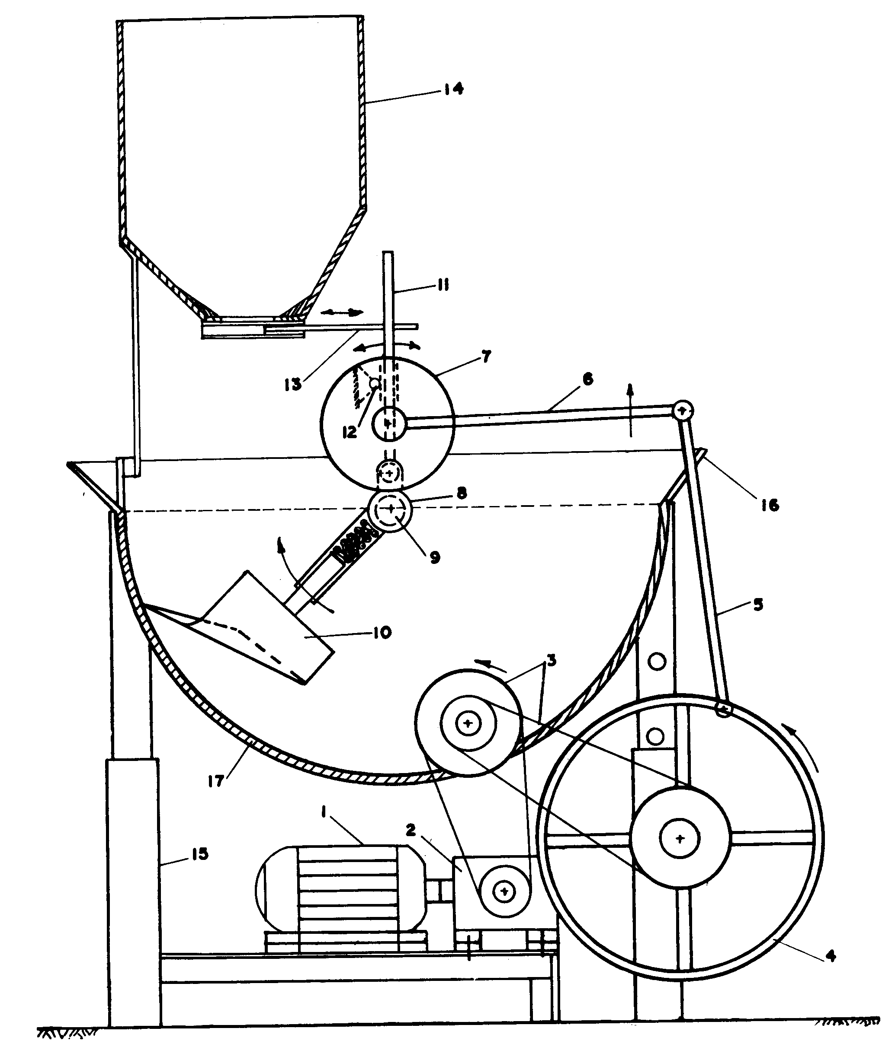

Fig. 3 End view of gari frying machine;
I - electric motor; 2- speed reducer; 3- chain drives; 4 - eccentric wheel; 5- lever, linkage; 7- 49 tooth gear, 8- 15 tooth gear; 9- paddle shaft; I0-paddles, 11- metering lever; 12- fulcrum, 13-metering gate; 14- hopper. I5- telescoping legs, I6-shielding lip for trough 17-layer of clay between inner and outer layers of steel plates.

paddles inside the 1.7m long, 57cm dia semi-circular trough. The paddles, shaped as shown in Fig. 3, are spaced with a small overlap, one over the next, and are angled relative to the axis of the trough in such a way as to form discontinuous flight of a sort of screw conveyor. Fig. 3 also shows the composite structure of the trough consisting of an interior layer of 3" galvanized steel sheet, an exterior layer made of sections cut from 44- gal oil drums and then a one-centimeter thick layer of clay sandwiched between and bonded to the interior and exterior layers. The composite structure and especially the layer of clay make for high heat capacity and heat retention ability of the trough and help to make the temperature of the frying surface uniform, as the exterior layer is directly fired. The frying trough is mounted at an axial inclination that may be adjusted between 0° and 20° to the horizontal, through the four telescoping legs shown in Fig. 3 and Fig. 4.

3.1 The Drive Train
The paddles oscillate within the trough through about 180⁰ at 40 reversals per minute. The driving mechanism which makes this possible is illustrated in Fig. 3. The drive train consists of a 0.75KW single-phase, 1420-rpm electric motor (l) directly coupled to a 1:10 speed reducer (2) which, in turn, drives a two-stage chain-and-sprocket arrangement (3) to further reduce the speed. The final shaft of the second stage chain and-sprocket drive carries an eccentric wheel (4) which rotates at 48rpm. A lever (5) mounted on a bearing on the
rim of the wheel is hinged to the linkage(6) which in turn is rigidly attached to the shaft of a 49-tooth spur gear(7). This gear (7) is in mesh with a 15-tooth gear (8) keyed on the shaft (9) which carries the gang of sixteen paddles (10). The rotational motion of the eccentric wheel is converted to the reciprocating motion of the spur gear (7) through the lever (5) and linkage (6). Gear (8), being in mesh with gear(7) also reciprocates and carries with it the gang of paddles. As a result of the gear ratio and the point the gears are made to mesh, the gang of paddles oscillates in the trough, through nearly a semi- circle at 48 reversals per minute, as illustrated in Fig. 5. Note that for one degree rotation of gear 7, the paddles rotate through about 3.27 degrees.

3.2 The Metering Device
The oscillation mechanism also actuates the metering device for the gari mash. This is done through a lever (11) hinged on the shaft (9) (see Fig.3). The lever which is constrained to turn about the fulcrum (12) engages the gate (13) at the bottom of the hopper (14). As the point of the lever (ll) hinged to shaft (9) oscillates with it, the lever turns about the point(12) and thus pushes gate(13) in and out there by metering the sifted gari mash from the hopper into the frying trough, once every two reversals. As can be seen from Fig. 5, the quantity of mash metred into the trough may be varied by changing the position of the fulcrum, F, or by changing the position of the hole in the gate, G through which the metering lever, L, passes.

3.3 The Hopper
The hopper is mounted in such a way that its opening is located off-centre and to one side of the trough as shown in Fig 3, also, as can be seen in Fig. 2 and Fig.4,the hopper is located at the raised end of the hopper. As illustrated in Fig. 5, the gari mash is metered into the trough as the paddles start swinging to the other side of the trough and so avoids scattering or spilling of mash that would otherwise occur if the mash were to contact the paddles as it falls into the trough of course, the shape of the hopper is such as to facilitate the flow of the mash and ensure complete emptying of its contents. The opening of the
hopper gate is adjustable to give a desired feeding rate.

3.4 The Firing System
The frying machine may be fired using gas, crude oil, diesel, kerosene, wood, charcoal, coal or farm waste, provided that the system is well designed to avoid contamination of the

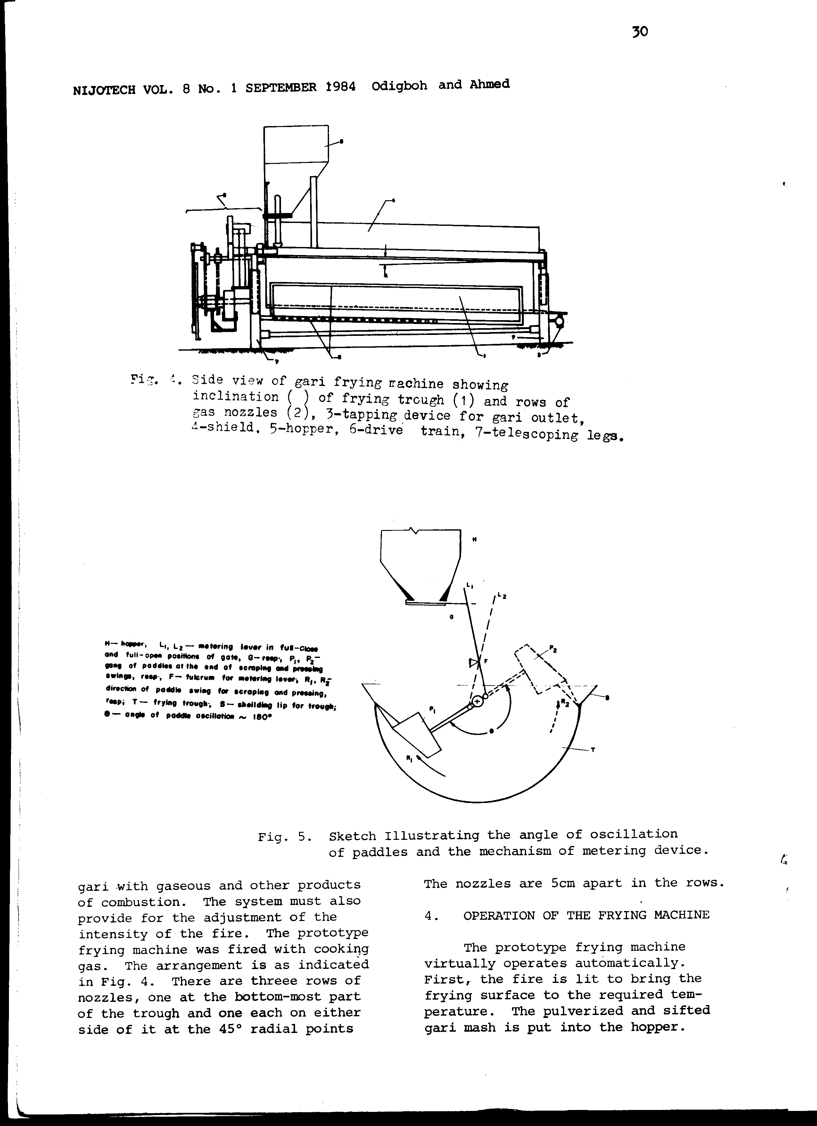

Fig.4. Side view of gari frying machine showing inclination ( ) of frying trough (1) and rows of gas, nozzles (2), 3-tapping device for gari outlet, 4-shield. 5-hopper, 6-drive train, 7-telescoping legs

Fig. 5. Sketch illustrating the angle of oscillation of paddles and the mechanism of metering device.
H-hopper, L_{1,}L_{2,}- metering lever in full –close and full-open position of gate, G-rasp, P₁,P₋ gong of paddles at the end of scraping and pressing swings, rasp, F – fulcrum for metering lever, R₁, R_{2,} direction of paddle swing for scraping and pressing, rasp, T-frying troughs - shielding lip for trough, θ-angle of paddle oscillation 180.

gari with gaseous and other products of combustion. The system must also provide for the adjustment of the intensity of the fire. The prototype frying machine was fired with cooking gas. The arrangement is as indicated in Fig. 4. There are three rows of nozzles, one at the bottom-most part of the trough and one each on either side of it at the 45° radial points
The nozzles are 5cm apart in the rows.

4. OPERATION OF THE FRYING MACHINE
The prototype frying machine virtually operates automatically. First, the fire is lit to bring the frying surface to the required temperature. The pulverized and sifted gari mash is put into the hopper. From previous experience, the trough is set to a certain inclination and the corresponding gate opening is selected. When the trough has attained the required temperature, the machine is switched on and frying commences. As the paddles swing to and fro, the gari mash is metered continuously into the trough as earlier described. Due to their shape and orientation, the paddles press the gari mash against the hot Surface of the trough when moving in one direction. While moving in the opposite direction (see Fig.3), they scrape the mash off, stir it and move it down the slope of the trough. By appropriately adjusting the amount of mash metred, the inclination of the trough and the intensity of the fire, frying is completed when the mash traverses the length of the trough and reaches the outlet. The fried gari continuously flows out and is collected at the outlet. Thus, the prototype is a continuous flow machine that closely simulates the manual gari frying technique. The reciprocating motion of the paddles is a unique feature of the machine; there is no unproductive motion of the paddles which would be there if they were simply rotating as is the case with the gari firers of the large gari plants mentioned earlier.

4.1 Performance Test
Full scale performance tests on the prototype gari frying machine will involve all the unit operations proceeding garification, as illustrated in Fig. 1. Nevertheless, such tests will have to be done to provide quantifiable specifications and calibrations for the machine. But from some limited tests so far carried out, the machine was found to perform very satisfactorily indeed. At one setting of the machine, well-fried gari at 15% moisture content (wet basis) was produced at the rate of about 1.lkg per minute. This gives an average capacity of 66kg of fried gari (at 15%, m. c., w. b) per hour. Since the gari mash used was at 37.5% moisture content (w. b.), this capacity is equivalent to about 81kg of gari mash per hour. On the basis of the percentages given in Fig.1.81kg of gari mash would require 184.5kg of cassava roots. Assuming a ten-hour per day operation, it follows that the prototype gari frying machine can handle gari mash from about 1.85 metric tons of cassava roots per day. This means that, according to the classification of scales of operation referred to earlier (Plucknett, [l]. this prototype machine is suitable for small-to, medium scale gari processors. The quality of the gari produced was very good and comparable to a sample fried manually, in terms of general appearance, particle size distribution and swelling power.

- MANUAL VERSION OF THE GARI FRYING MACHINE
In order to cater for the needs of the majority of processors who do
not have access to electricity, the gari frying machine was modified for operation without an electric motor. This was done by disconnecting the second stage chain drive from the eccentric wheel. Then the linkage that actuates the 49-tooth spur gear was extended to a length of 75cm on either side of the gear. At one end of the extended linkage, a weight was attached. The weight was made large enough to pull down the linkage with only a slight manual assistance and cause the rotation of the spur gear through an angle that can bring the gang of paddles to its upper-most position at one side of the trough (see Fig. 6),. At the opposite end of the linkage, a handy handle was provided for a seated operator.
To operate, the extended linkage is manually pulled down to bring the paddles to their upper-most position at the opposite side of the trough. Then, the linkage is released and the weight at the other end swings the paddles back to their former position. Thus, the pressing and scrapping processes described in Section 4 are accomplished by simply pulling and releasing the extended linkage as illustrated in Fig. 6.This means that the operator sits comfortably away from the fire, pulls and releases the linkage 10 to 20 times

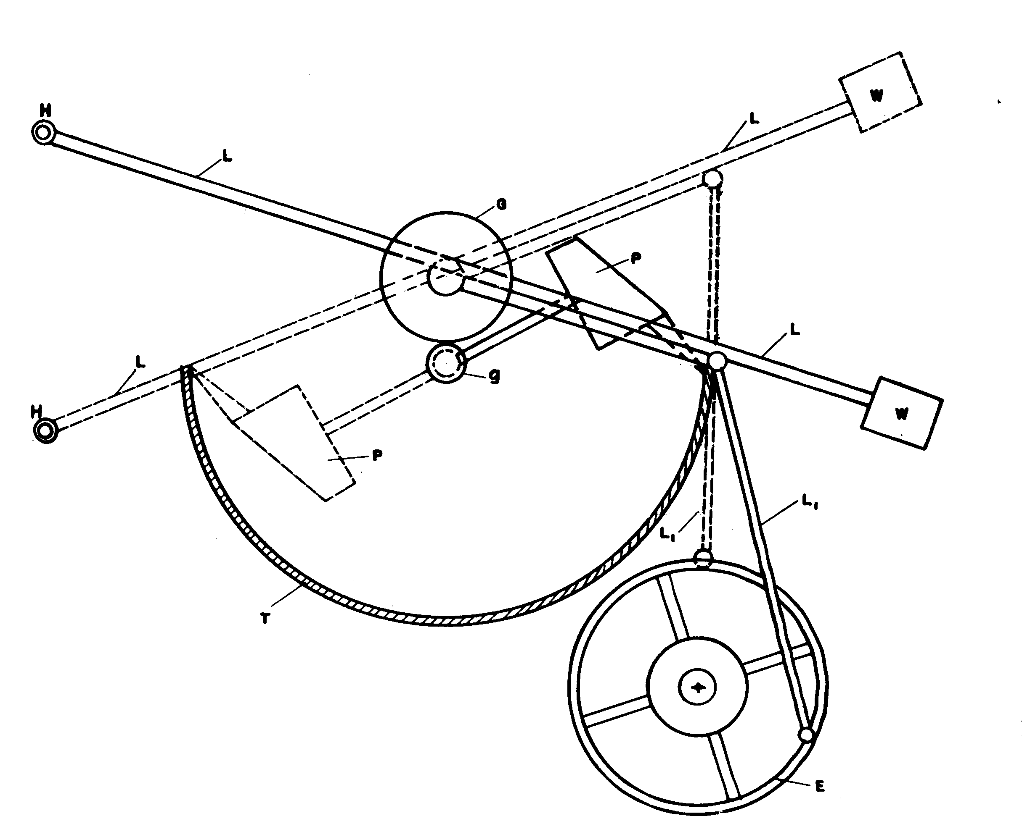
Fig.6. Sketch illustrating modification of drive for manual operation.
E-eccentric wheel; L₁-lever; w-weight L – extended linkage; P –paddle; G – big gear; g-small gear; H- handle; T- trough.

In one minute to produce a continuous flow of gari at about 0.35 to 0.75kg per minute or 20 to 45kg per hour. This is considered a very important development. The tedium and drudgery of the traditional method of gari frying are effectively removed while producing a more wholesome product at a much faster rate. What is more, no experience or special skill is required to operate the manual version of the gari frying mach.

6. CONCLUSION
There is every justification to consider the prototype, as designed and built, a practical and functional gari frying machine suitable for small and medium scale gari processors. Its Successful modification to provide a manually operated version is a significant extension of this work whose importance is emphasized by the very large number of peasant processors for whom the manual version is intended.

ACKNOWLEDGEMENT
The defunct OFN is hereby gratefully acknowledged for providing the funds for this work.

REFERENCES:
- Plucknett, D.L. Ed., Small-Scale Processing and Storage of Tropical root Crops, West view Tropical Agriculture Series, No.1, West view Press, Boulder, Colorado, 1979.

- Ngoddy, P.O. Gari mechanization in Nigeria: the competition between intermediate and modern technology. In Appropriate Technology Problems and Promises, (Jaquier, E. ed) 1976, pp. 260-275.

- Odigboh, E.U. Instruments for measurement of the thermal conductivity of solid food materials. Nigerian Journal of Engineering and Technology, Vol. 1, 1978, pp. 1 - 14.

- Ibe. D.G. A partially mechanized village-scale gari production system. Proceedings of Nigerian Society of Agricultural Engineers, Vol. 3, 1979, pp. 223-229.

